DATABASE DESIGN AND IMPLEMENTATION

Chanpreet Singh:991734438

MARCH 12,2024

1. Conceptual Model

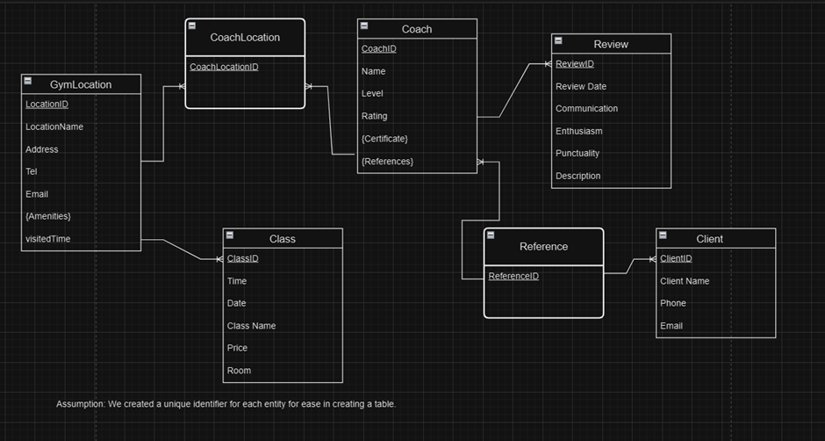

1. Relational Database model

GymLocation:



|  |  |  |  |  |  |
| --- | --- | --- | --- | --- | --- |
| LocationID | LocationName | Address | Tel | Email | VisitedTime |



Amenity:



|  |  |  |
| --- | --- | --- |
| AmenityID | LocationID(fk) | Amenity |

Certificate:

|  |  |  |
| --- | --- | --- |
| CertificateID | CoachID(FK) | CertificateName |



Coach:



|  |  |  |  |
| --- | --- | --- | --- |
| CoachID | CoachName | Level | Rating |



CoachLocation:



|  |  |  |
| --- | --- | --- |
| CoachLocationID | CoachID(FK) | LocationID(FK) |



Review:

|  |  |  |  |  |  |  |
| --- | --- | --- | --- | --- | --- | --- |
| ReviewId | ReviewDate | Communication | Enthusiasm | Punctuality | Description | CoachID  (FK) |

Reference:



|  |  |  |
| --- | --- | --- |
| ReferenceID | CoachID(FK) | ClientID(FK) |



Client:



|  |  |  |  |
| --- | --- | --- | --- |
| ClientID | ClientName | Email | Phone |

Class:

|  |  |  |  |  |  |  |
| --- | --- | --- | --- | --- | --- | --- |
| ClassID | Date | Time | ClassName | Price | Room | LocationID  (fk) |